- Login into Gmail.
- Click on Search box.
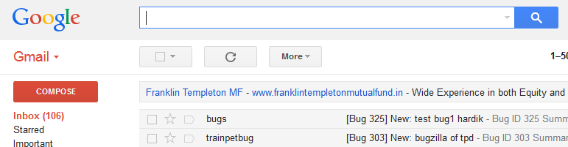

- Type: from: bugs@trainpetdog.com then click Down bar.

- Then click on Create filter with this search >>
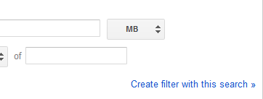
- After this click the condition: Never send it to Spam
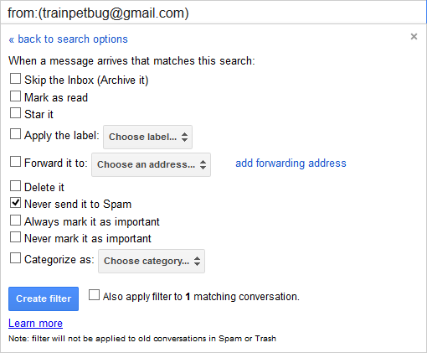
- At last Click on Create Filter.

